MENU DEVELOPMENT QUIZ
- How many servings of fruit needs to be served in a week?_____

- Which vegetable is not a starchy vegetable:

  - Corn.
  - Peas
  - Potatoes
  - Green beans
- What is the 1/3 sodium requirement for a weekly lunch menu?
  - 600mg
  - 766mg
  - 1000mg
  - 2500mg
- What is the 1/3 fiber requirement for weekly lunch menu?
  - >10g Fiber
  - <10g Fiber
  - >12g Fiber
  - <7g fiber
- True or False. A benefit of fiber is that can help control blood sugar.
- True or False. Beans can be counted as protein and vegetable requirement?

Nutrition Label for Kielbasa
Serving Size: 2oz
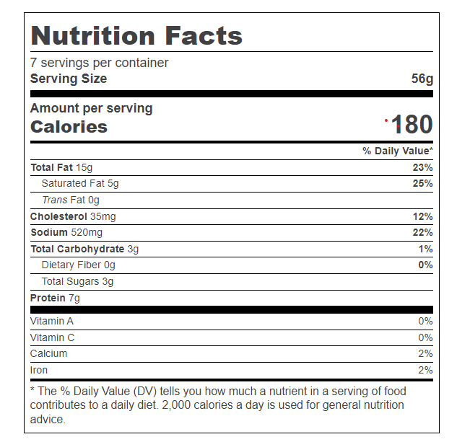

Ingredients
Meat Ingredients (Pork, Beef) Mechanically Separated Turkey, Water, Corn Syrup, Natural Flavors, Contains 2% Or Less: Salt, Dextrose, Soy Protein Concentrate, Sodium Phosphate, Monosodium Glutamate, Sodium Erythorbate, Sodium Nitrite. Made With Beef Collagen Casing.

Nutrition Label for Kielbasa
Serving Size: 2oz
- How much sodium is in this product?
- What are the other names for salt in the above ingredient list?
- If you were to eat 4oz kielbasa how much sodium are you eating? What is the % Daily Value?
- Carrots and sweet potatoes are a good source of what vitamin?
  - Vitamin b1
  - Calcium
  - Starch
  - Vitamin A
- True or False. Vitamin C can help heal wounds.
- Which one of these are considered unsaturated fats?
  - Olive oil
  - Palm oil
  - Ghee
  - Coconut oil
- True or False. Fats are needed to absorb Vitamins A, D, E, and K.
- _______ is the 1/3 requirement of Saturated fat.
- What foods are considered sources of carbohydrates?

