Cilantro Lime Cod
Serving Size: 3oz Fish, 1oz cilantro Sauce
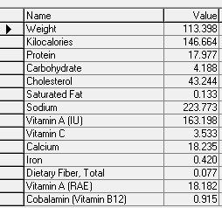
Cranberries in snow (Made with Splenda Sugar Blend)
Serving Size: 1/2c
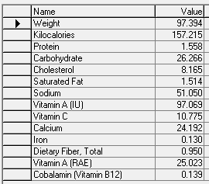

Christmas Cranberry Salad(made with sugar free gelatin and Splenda Sugar Blend)
Serving Size: 1/2c
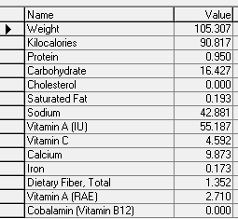
Cranberry and Apple Salad
Serving size: 1/2c
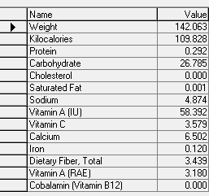

Zesty Chicken Taco soup
Serving Size: 1 cup (3oz Chicken, 1/2c Vegetables)
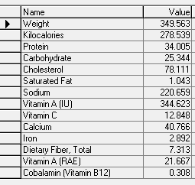
Rice Pudding with Cranberry Sauce
Serving Size: 1/2c
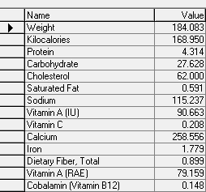

Southwestern Style Stuffed Red Bell Pepper
(1 red pepper, 3oz Beef, 1/4c corn, 1/8c green Chile, 1/3c Tomatoes)
Serving Size: 1 Pepper
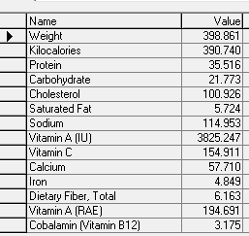

Autumn Wild Rice:
Serving Size: 1 cup (1/2c Brown and Wild rice, 1/2c Fruit and vegetable mixture)
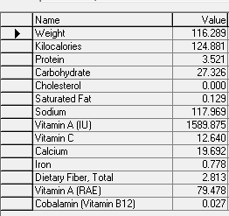

Apple Spice Pork Chops:
Serving Size: 3oz Pork chop, 1/2c Apples
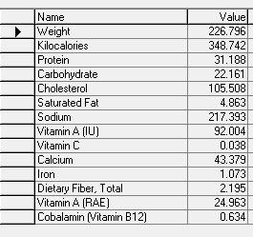

Southwest Pasta Salad
Serving Size: 3/4c
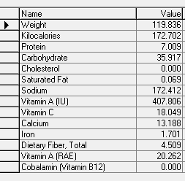

Broccoli with Apple Salad
Serving Size: 3/4c
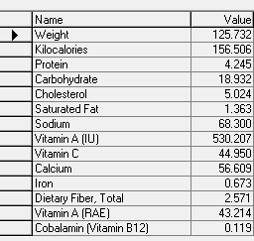
Chicken with apples, carrots, and grains
Serving Size: 3oz Chicken, 1/2c Grain, 1/2c Apples, 1/2c Carrots
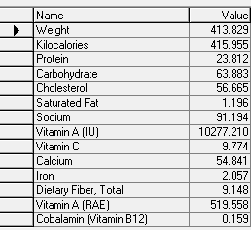
Pork Fajitas:
Serving Size: 3oz Pork, 1/2c peppers and onions, 1 6in flour tortilla
